GenAI Handson 1

Name: Rithvik Hemanth
SRN: PES2UG23CS484
Section: H

Observation:
The transformers library acts as a bridge between our python code and AI models available on Hugging Face. It makes handling models simpler by using a function called pipeline(). Pipeline handles everything automatically. (preprocessing, inference and
postprocessing). We will be looking into two models - 1) distilGPT2 2) gpt2
set_seed(42)

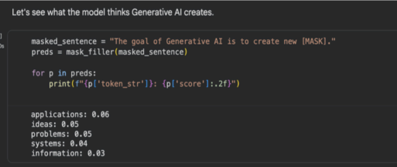
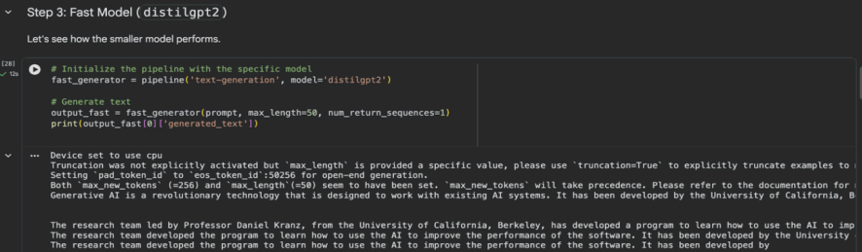
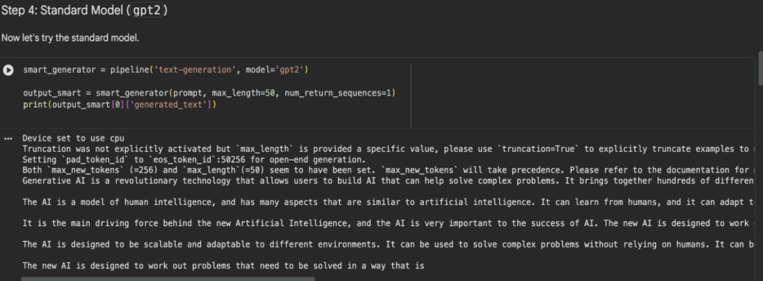
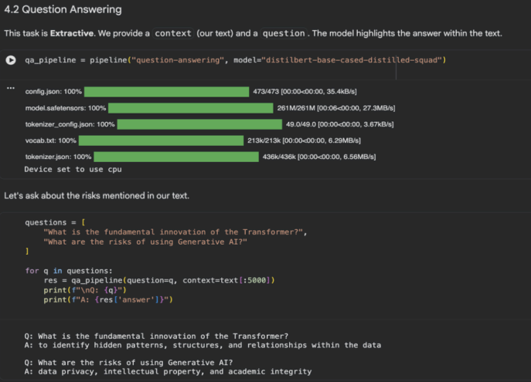

Seed(70)

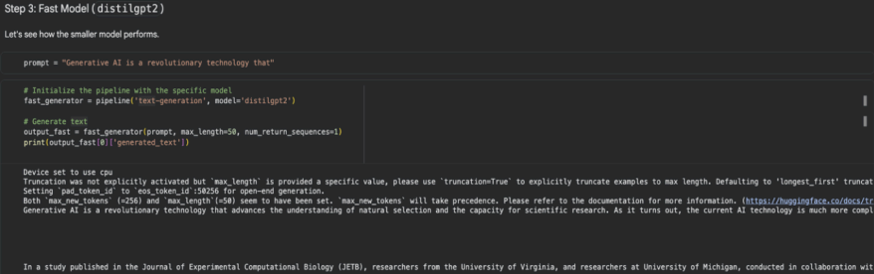
distilGPT2 remains fast but inconsistent across different seed values.

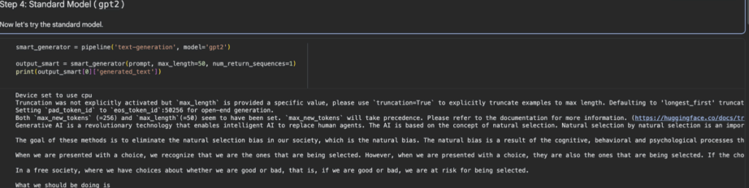
Although it is readable , the phrasing and sentence order for seed value 70 is different in comparison to seed value 42. The model seemed to be better for seed value 42 as it has less repetition and the logical flow was better.

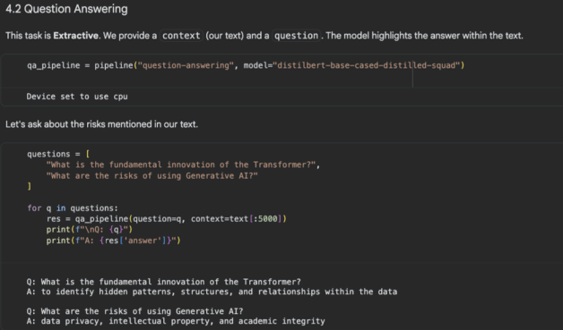
It remains the same for both the seed values

Conclusion:
There were noticeable changes with respect to change in seed value while comparing the two models (distilGPT2 and GPT2). However , summarization ,question answering and masked language modelling outputs did remain quite similar to each other indicating they are not much affected by the seed value.

